Team 5 | CSC 4350 Software Engineering

Booking Website for Salon Businesses Use Case

Team Members:

1. Brian Le (Bao Le)

2. Guillermo Clara (GC)

3. Jisoo Park (JP)

4. Aleeza Iftikhar (AI)

5. Jennie Vu (JV)

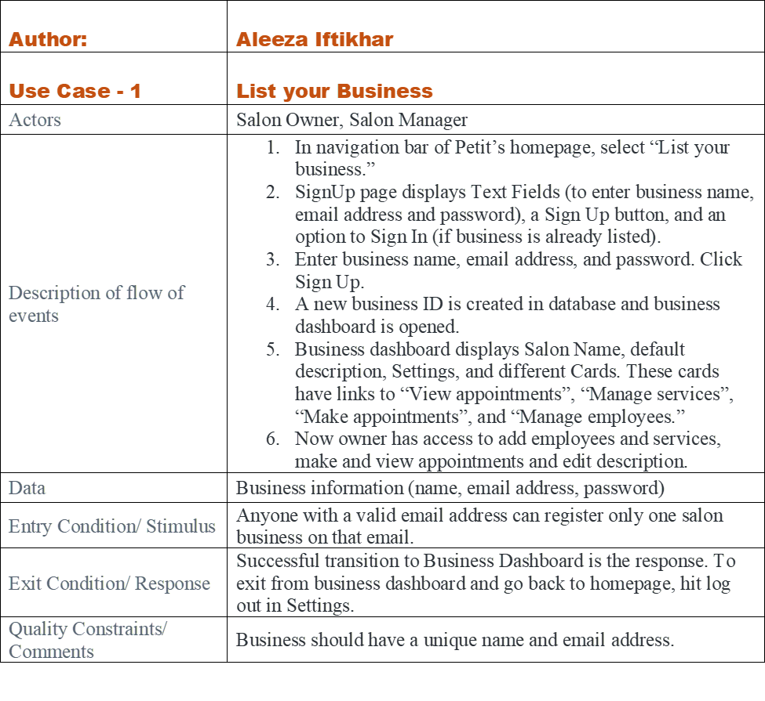

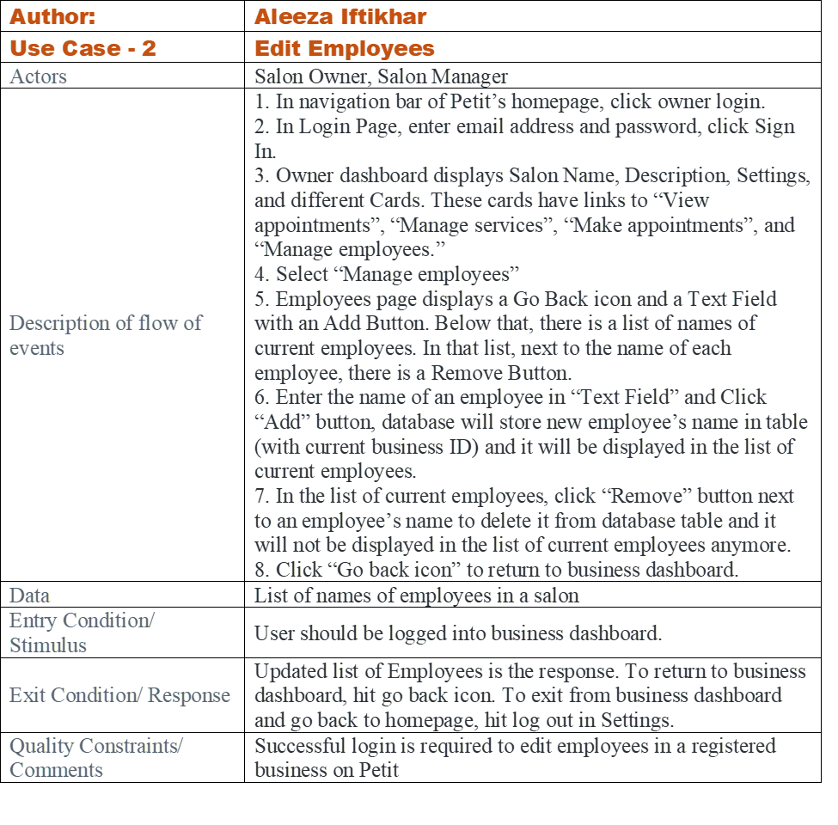

| Author: | Guillermo Clara |
| --- | --- |
| Use-Case 1 | Edit services |
| Actors | Business Owner, Business Database |
| Description of flow of events | 1. On homepage click login button  2. Enter account credentials  3. Click login button  4. Select Manage Services in the business dashboard  5. Perform action (If delete, click trash icon next to service, If add, enter text in input box and click Add)  6. Click save changes button  7. Continue editing or go to another page in the menu |
| Data | List of services from a salon |
| Entry Condition | When the Salon Owner/Manager should be logged in the business dashboard |
| Exit Condition | The Salon Owner/Manager is satisfied with changes made to services list |
| Quality Constraints | None |

| Author: | Guillermo Clara |
| --- | --- |
| Use-Case 2 | Make appointment |
| Actors | Customer |
| Description of flow of events | 1. On homepage click on Salons  2. Find and click their desired salon  3. Select the date, service and stylist desired  4. If available, click on time-slot  5. Click confirm appointment |
| Data | Available time slots per day per employee |
| Entry Condition | When there is at least one stylist available |
| Exit Condition | When there is no stylist or timeslot available.  When the customer is satisfied with their appointment made. |
| Quality Constraints | Transaction should be completed as quickly as possible |

| Author: | Brian Le (Bao Le) |
| --- | --- |
| Use-Case 1 | View confirmation of the appointment |
| Actors | Customer |
| Description of flow of events | 1. Receive confirmation link to email  2. Click on the link from the email  3. View the information about the appointment  4. Can cancel the appointment by clicking the “cancel” button and the end of page  5. Save it to note |
| Data | Email from they made the appointment |
| Entry Condition | When there the appointment is still active |
| Exit Condition | When they already canceled the appointment. |
| Quality Constraints | No need to log in to see the confirm page |

| Author: | Brian Le (Bao Le) |
| --- | --- |
| Use-Case 2 | Cancel appointment |
| Actors | Customer |
| Description of flow of events | 1. Click on the link from the email when making an appointment.  2. Find and click on the “cancel” button at the end of the confirmation page.  3. View cancel appointment successfully  4. If they want to make a new appointment, click on the button “click here” at the end of the form |
| Data | From they have made an appointment |
| Entry Condition | When they have a confirmation page |
| Exit Condition | When the appointment has been canceled successfully |
| Quality Constraints | Transaction should be completed as quickly as possible |

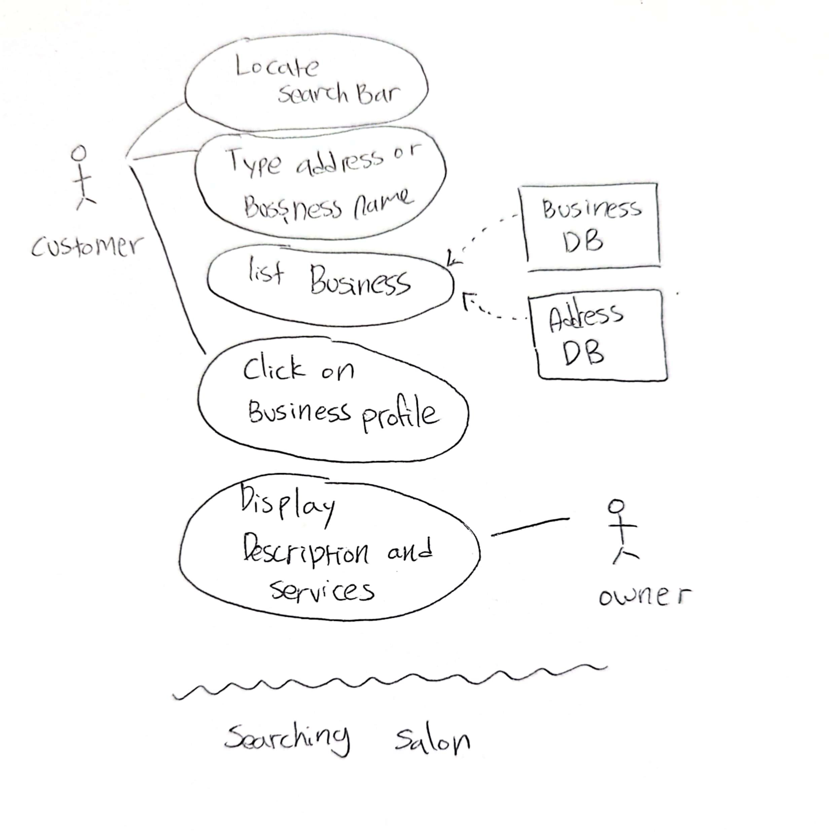

| Author | Jisoo Park |
| --- | --- |
| Use-Case 1 | Searching Salon |
| Actors | Customers |
| Description of flow of events | 1. On homepage locate the search bar  2. Type in the desired address or name of the business  3. Look for the desired businesses in the list of filtered businesses  4. Click on the profile of the business to see the list of services. |
| Data | Businesses Database  Address Database |
| Entry Condition | When the user types information into the search bar. |
| Exit Condition | When the desired salon was found.  When the user could not find a salon that meets their needs. |
| Quality Constraints | The search should be related to the name and the address only. Not the services. |

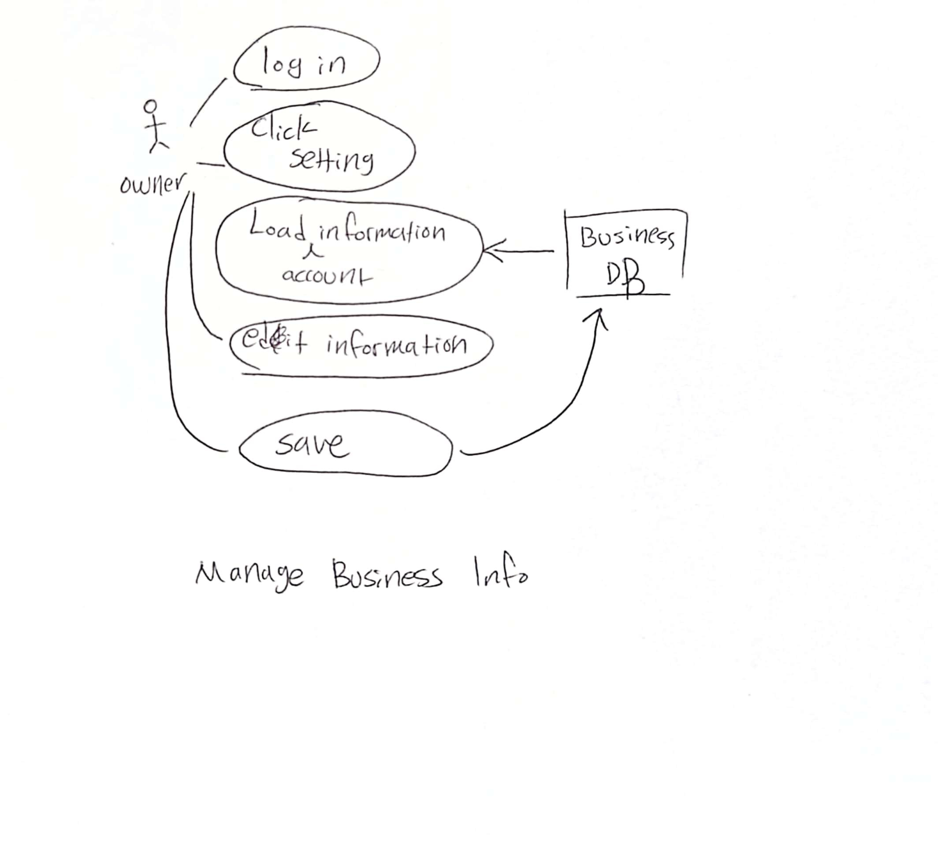

| Author | Jisoo Park |
| --- | --- |
| Use-Case 2 | Manage Business Information (Business Description and User info) |
| Actors | Business Owner, Business Manager |
| Description of flow of events | 1. Log in to the owner account  2. On the owner dashboard, the owner will see “Settings”  3. Click Settings  4. The owner will see the text box where they are able to change the Business Description  5. Click the save changes button (This will update the database) |
| Data | Employee Database  Businesses Database {Business Description Column} |
| Entry Condition | When the owner enter the owner dashboard |
| Exit Condition | When the save button is pressed |
| Quality Constraints | none |

| **Author** | **Nga Vu** |
| --- | --- |
| Use-Case 1 | Appointment filtering |
| Actors | Customers |
| Description of flow of events | 1. On homepage, select a business  2. Locate and click the “Book Appointment” button  3. Select a service from the services dropdown  4. Select an employee from the employees dropdown  5. Select a date from the date picker  6. Click the search button to see the availability of the selected employee |
| Data | Services database  Employee database  Availability database |
| Entry Condition | User selects options from the services, employees, and date picker fields. Then clicking search to initiate the filter |
| Exit Condition | Search button is clicked |
| Quality Constraints | None |

| **Author** | **Nga Vu** |
| --- | --- |
| Use-Case 2 | Appointments section |
| Actors | Customers |
| Description of flow of events | 1. After the Search button is clicked, time slot buttons will be available to be selected. The time slots will be divided by Morning and Afternoon for a better user experience  2. The user selects an available time slot (unavailable time slots will be hidden from users)  3. Clicking the desired time slot will direct the user to the confirmation page. |
| Data | Services database  Employee database  Availability database |
| Entry Condition | User selects a time slot button |
| Exit Condition | User selected an available timeslot  No timeslot found for that day |
| Quality Constraints | All timeslot picked for certain date |

| Author: | Guillermo Clara |
| --- | --- |
| Use-Case 3 | Account recovery |
| Actors | Business owner, User Database, Recovery Database |
| Description of flow of events | 1. On homepage click Business Portal  2. Go to Forgot Password  3. Enter email of account  4. Click on request recover button  5. Enter code sent to email  6. Click submit code button  7. Enter new password  8. Save changes |
| Data | Recovery code (sent to email) |
| Entry Condition | When the user is not logged in and forgot his/her password |
| Exit Condition | When the password changes are applied to the User database |
| Quality Constraints | Email with code has to be sent in a timely manner |